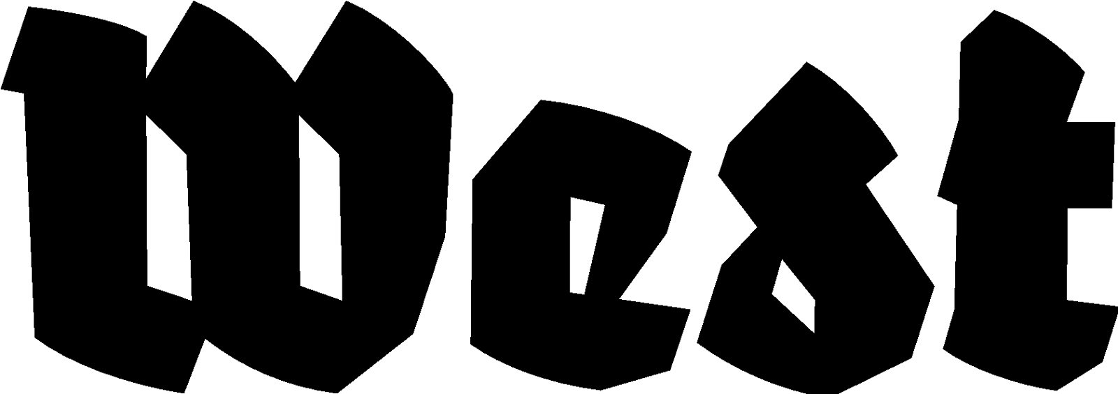

Press announcement 07.08.2024

GEEL EN ZWART
GUIDO SPRING

Presentation: 07.09.2024, 20:00 - 02:00 hrs
Location: West Den Haag in the form. American embassy, Lange Voorhout 102, The Hague

Poetic sound portrait of Reykjavik: ‘Geel en Zwart’ (Yellow and Black)

Iceland captures the imagination, and Iceland's capital Reykjavik certainly does as well. The still-active volcanoes near the city, the spectacular lava fields, the geothermal pools, the ancient sagas, and the city life, far removed from the world outside the island, together form an enormous attraction. It is precisely the sounds of Reykjavik that can make clear why this city of contrasts is so appealing.

Yellow and Black. These colors, which can represent 'wind' and 'lava,' dominate Reykjavik and symbolize the city.

‘The freshly melted seaweed crunches, the flagpoles clatter and blend with the sounds of creaking gangplanks in the fishing harbour and honking geese. On a black beach, birds give an incredible concert. The blind use binaurally recorded sounds in Reykjavik to learn new routes. Sound is always present, and often the wind plays a significant role.’

The different soundscapes produced by Reykjavik and the sonic diversity play the leading role in this portrait, against the backdrop of the rugged landscape and the poetry of Broekhuysen. Guido Spring alternates sound impressions with short narratives that he created on the spot. Many sounds, poetry, and a limited amount of text. Many sounds, poetry, and a limited amount of text create a film for the ears.

Dutch poet and writer Laura Broekhuysen has lived in Reykjavik for ten years. In her poems, she describes a wandering between the city and the fjord. Life between nature and city, the richness of sound, and the Icelandic ambivalent saga hero Loki play an important role in her poetry. Two of her poems appear in this sound portrait.

The language used in the documentary is Dutch.
-
Guido Spring (1969) creates radio documentaries, including for VPRO, and sound portraits of cities. He previously made the portraits ‘Blauw en Groen’ (Blue and Green) about Kristiansand (Norway), ‘Groen en Paars’ (Green and Purple) about London (UK), and ‘Rood en Wit’ (Red and White) about Bratislava (Slovakia).

‘Geel en Zwart’ was made possible with the support of West Den Haag, Perdu, Rotterdamse Blindenbelangen, WORM Art Center, Vereniging Onbeperkt Lezen, Oogcontact Amsterdam, Konrad Boehmer Foundation, Stichting Blindenhulp, Stichting Blindenbelangen, and Verhalenhuis Belvédère.

For more information, please contact us: at info@westdenhaag.nl or +31(0)70.3925359

The program of West is made possible by a.o.: Municipality of The Hague and the Ministry of Education, Culture and Science.

