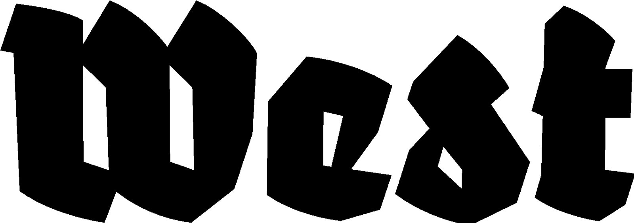

Press announcement: 06.01.2025

Mount Analogue Observatory
René Daumal

Exhibition: 28.02.2025 — 03.08.2025 Opening: 28.02.2025, 20:00 hrs.
Location: West Den Haag in the former American Embassy, Lange Voorhout 102, The Hague

In René Daumal’s novel ‘Mount Analogue’, a group of mountaineers sets off in search of an invisible, but geographically locatable mountain that is as real as it is metaphysical: it is the absolute link between heaven and earth, gods and men, an analogy for the ascent towards higher levels of consciousness. However, the expedition only reaches the foot of the mountain.

Ending abruptly in the middle of a sentence, the manuscript finishes with a comma that gives rise to ever new readings and interpretations. Since its posthumous publication through Daumal's wife Vera in 1952, this “novel of symbolically authentic non-Euclidean adventures in mountain climbing” has never ceased to exert a gravitational force on musicians, artists, writers, architects, explorers, literary scholars and spiritual seekers.

Commonly read as a journey towards oneself, ‘Mount Analogue’ is also an encyclopedic pastiche, a collage of heterogeneous genres and text forms: myth, philosophical speculation, travel journal, scientific treatise, poetical confession. The exhibition will focus on this other side of the novel. Looking at its manifold reflections, references, and subtexts, a singular history of ideas takes shape in the kaleidoscope of Daumal’s only seemingly naive writing style. It reveals an investigation into the metaphors, models, and mechanisms of thought, the world of symbols and values, mathematical theorems and geographic problems, the threshold between the visible and the invisible, mythologies and facts: an investigation that permeates the text from its main motives to single subordinate clauses.

Or in the words of the narrator: “All of us keep a fairly extensive collection of diagrams and inscriptions in our heads; and we have the illusion we are 'thinking' the loftiest scientific and philosophical thoughts when, by chance, a few of them fall into a pattern which seems neither too conventional nor too novel. It happens as if by the effect of draughts or cross currents, or simply by the result of their own constant shiftings, like the Brownian movement which displaces particles suspended in a liquid.”

This exhibition is curated by Anton Stuckardt, co-founder of publishing house Zero Sharp, Berlin.

For more information, please contact us: info@westdenhaag.nl or +31(0)70.3925359

The program of West is made possible by the Municipality of The Hague and the Ministry of Education, Culture and Science.

